CH 3.0.0

User’s guide for CH Client

Programmer: Claude Hanssens

Basic description of CH Programs 3.0
This program has been developed for Microsoft Flight Simulator on the Internet or a local network. It is also possible to use CH Programs on a single computer or over the Internet.

The program is actually composed of 3 separate programs:
- The CH Client 3.0
- The CH Server 3.0
- The CH Data Manager 3.0

The CH Client takes information from Flight Simulator 98, 2000, or 2002 and sends it to the CH Server through a TCP/IP network. The CH Server displays the information received from the client’s flight simulator through CH Client. The information in CH Server will be displayed in a tabular format on a special form. Another form will show the aircraft on a radar screen. This radar screen will also display other information like NAVAIDS (VOR, NDB, frequencies...), geographical data and airports. This information is taken from a Microsoft Access database. The CH Server part has also the capacity to generate “Devil orders”. These are commands sent to the flight simulator when connected. The server can manipulate the weather environment, aircraft systems, position and navigational equipment. CH Server has been designed to act as a host and a server client. People can use the program to connect multiple pilot and air traffic controller users into a network.

Limitations of design
CH Programs has been developed to support the needs of our fans through feedback. The design and functionality were developed for a specific use. If you decide to use CH Programs outside the original design, it may work or it may not, or you won’t be able to use it to the full extent.
The main ideas on which CH Programs are based are:
- CH Programs 3.0 was designed for use on the Internet or through a Local Area Network. This has a few consequences.
- The installation and testing can be done while the users have direct contact: they can talk directly with each other.
- There are no vocal radio communication features included in CH programs. You must own a separate radio communication system. Roger Wilco is the preferred choice.
- CH Programs 3.0 was designed for use by PC and Flight Simulator Power users.
- Version 3.0 now has an automatic install feature, but there might be some configuring required which will be discussed later.
- It requires a fully operational TCP/IP network. The users must be able to set up such a network and be able to coordinate the availability of service. In a club, there is generally at least one person able to do so.
- Users must have knowledge in interoperating earth geographic coordinates, weather data, and aerodynamics.
- Must have knowledge concerning the capabilities of Microsoft Flight Simulation: weather settings, aircraft settings, ect.

Version and Upgrade
Actual version of CH Client is 3.0.0.
Upgrades to this version are expected.
These upgrades can be minor or major upgrades or a new version.

Changes since version 2.0.0

New:
• Easy self-installation from one file
• Visual Basic Runtime files are now auto-installed.
• No longer requires the FS98class.dll or FS6IPC.dll for FS98 users
• Added a login ID option: A security login function used to pilots into a private session.
• Added an .ini file: Pilots can save unique preferences and settings by editing this simple file.
Such options that can be saved are the server IP address, Callsign, communication option,
and login name.
• Integrated a controller to pilot text messaging system: CH Server operators can contact pilots
who have not established voice radio communications. The service will also allow pilots the ability
to receive vital information from ATC such as ATIS information, airport/session status,
multiplayer information and more! The text messaging will appear on the top of the screen
in flight simulator as a single line in-red text, similar to receiving default weather or chat
messages.

Distribution
CH Programs 3.0 is available:
- For download on the Internet
- On CD-ROM (made on request only through Claude Hanssens)

Both versions have exactly the same functionality.
The CD-Rom version also includes:
- Sound files

Installation

CH Client 3.0

If you have any previous version of the CH Client, you must first uninstall it:
- Start-Settings-Control Panel-Add/Remove programs
- Click on “CH Client”, if in the list.
- Click on the "Remove" button.

To install CH Client, simply run the “Setup” program. After install is complete, you might have to
restart your computer.

Very important:
If you wish to use CH Client 3.0, you need to have some files installed:
- For FS98, FS2000 and FS2002, FSUIPC.dll version 2.77 or higher from Peter Dowson must be installed in the Flight simulator MODULES folder. The FS6IPC.dll is no longer required for FS98 users. The FSUIPC file can be found at http://www.schiratti.com/dowson.html.
Typical path to install on FS98 is C:\Program Files\Microsoft Games\FS98\Modules
Typical path to install on FS2000 is C:\Program Files\Microsoft Games\FS2000\Modules
Typical path to install on FS2002 is C:\Program Files\Microsoft Games\FS2002\Modules
NOTE: For users who have one or more of these flight simulator programs installed on the same computer, you will need to have the FSUIPC.dll file in each program modules folder.
IMPORTANT! After downloading the FSUIPC file, it will be in a compressed form known as a .zip file. You must extract the file, uncompressing it to the original size and form. You will need a program that does this. We recommend using a program called WinZip. It is a Shareware and can be downloaded at http://www.winzip.com. The only file you will need from the FSUIPC.zip download is the FSUIPC.dll. The other files are not required.
- CH Programs was designed using Visual Basic. You will need to download Visual Basic Runtime file 6.x or higher.

User’s guide

General
CH Client is a program that communicates with Microsoft Flight Simulator and sends data to a main server. The main server, known as CH Server (when used as a host) receives and interoperates data sent by CH Client and displays the information to the server. When connecting to CH Server, CH Client will continuously report information to the server until disconnected by the client user. CH Server can manipulate your aircraft, position and any other function upon the request of the operator. See the CH Server Manual for further details. The main purpose for CH Client is to connect to CH Server so that ATC and radar services can be provided.

After installing CH Client, you can start the program from either the CH Client directory or from the PROGRAM FILES menu under the Windows START option. After starting the program, you will be presented with a small interface. You will be required to enter information in first three boxes.
(See example below)
NOTE: Your computer must be connected to the Internet or LAN and have your flight simulator program running.
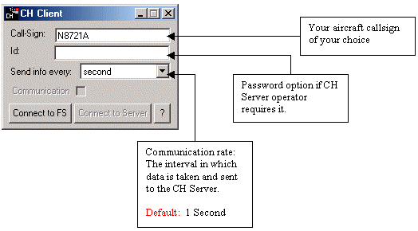

After you enter your aircraft callsign, password (if applicable) and data transfer rate, you can establish a connection to your flight simulator. Simply click the “Connect to FS” button on the CH Client interface. If all goes well, you will receive a message stating “Connection to FS successful!” Acknowledge the prompt by clicking “OK”. (See example below)

NOTE: The password “ID” box is not needed to connect unless the CH Server operator requires it. If no password is required, leave the default “CHPilot” ID in the box.

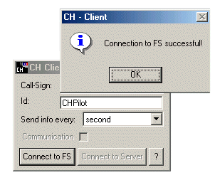

After establishing a connection with your flight simulator, you can connect to the CH Server. Simply click the “Connect to Server” button; you will be prompted to enter either the IP address or computer name of the CH Server you want to connect to.
(See example below)
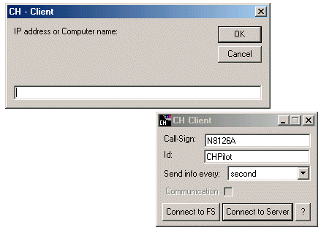

Once you enter the IP or computer name, press the “OK” button to request the connection. It should only take a few seconds to find the server and establish a connection. If connection is successful, you will see a prompt confirming it. (See example below)

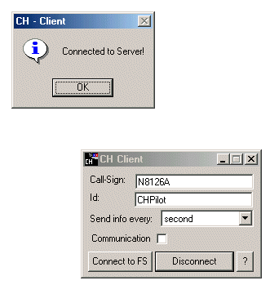

You must acknowledge the “Connected to Server!” prompt by clicking the “OK” button before CH Client will communicate with the server. At this point, you are now connected and ready to fly! You can minimize the CH Client program so that it is hidden.

Disconnecting from the server is very simple. Just click the “Disconnect” button. You will receive a prompt confirming the action. Acknowledge the prompt by clicking the “OK” button. (See below)

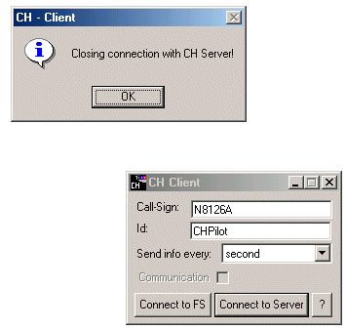

TROUBLESHOOTING: No unforeseen problems are anticipated. The program has been re-written and thoroughly tested to better support Microsoft Flight Simulator. If you are experiencing problems, please make sure you have done the following:

1. Downloaded and installed the correct version of CH Client 3.0. You can verify the version by clicking the “?” button on CH Client.
2. Be sure you have Peter Dowson’s FSUIPC.dll file version 2.77 or higher in your flight simulator MODULES directory. Here is how to verify:
- Start your flight simulator
- At the toolbar, you should see a “Modules” option. If not, your file is not install or not installed properly. (See note below) If you do see the “modules” option, then select it with the mouse and click FSUIPC. The FSUIPC interface should display more options. Make sure you are on the “About tab” and it should specify what version you are using.
(See example below)
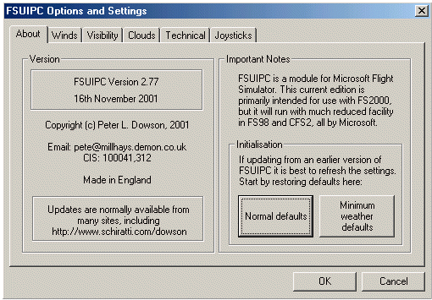
NOTE: If you cannot find the “Modules” option in the toolbar in flight simulator, you might not have copied the file into your flight simulator MODULES directory. Simply go to the directory and look for a file called “FSUIPC.dll”.
Typical path to find the file in FS98 is C:\Program Files\Microsoft Games\FS98\Modules
Typical path to find the file in FS2000 is C:\Program Files\Microsoft Games\FS2000\Modules
Typical path to find the file in FS2002 is C:\Program Files\Microsoft Games\FS2002\Modules
Or
under Windows find/search option (START-FIND or SEARCH), search for a “file” named FSUIPC.dll.
If you do not find the file specifically located in the FS/MODULES directory then you will need to get the file and copy it to that directory. If by chance you do see something similar in that directory, maybe named FSUIPC.zip, then you didn’t unzip the FSUIPC package and extract the FSUIPC.dll file into that directory properly. For details on how to do that, please review the installation instructions at the beginning of this manual.

Credits
Many thanks to:
Peter Dowson: for developing the FSUIPC

Disclaimer
CH Programs comes with no warranty or claim of fitness or reliability.
CH Programs is distributed AS IS, USE AT YOUR OWN RISK. The author of CH Programs has absolutely no affiliation what so ever with Microsoft® Corporation. Neither the author of CH programs, nor Microsoft Corporation shall be held responsible for any loss of data, down time, loss of revenue or any other direct or indirect damage or claims caused by CH Programs or FILES USED IN CONJUNCTION with CH Programs.

Redistribution Terms
CH Programs is SHAREWARE, and:
- MAY NOT BE sold.
- MAY NOT BE uploaded to, nor archived in, BBSs which charge file download fees.
- MAY NOT BE uploaded to, nor archived in, BBSs which are partly or wholly beneficially owned or operated by a commercial enterprise which is engaged in the sale of computer hardware or software.
- MAY NOT BE redistributed with computer hardware or software for which money is charged.
- MAY NOT BE redistributed by a commercial publisher in any form or under any pretext.
- MAY NOT BE redistributed on floppy disk, CD-ROM, nor in any other printed or electronic storage form for which money is charged, nor as part of a package for which money is charged. This prohibition includes but is not limited to any form of redistribution for which any type of materials or handling fees are charged.
- MAY NOT BE disassembled, decompiled, decomposed, decoded, nor reverse engineered.

Subject to the exclusions listed above, the archive containing CH Programs may be uploaded to BBSs and otherwise redistributed on a SHAREWARE basis as long as the original contents are not modified in any way.

THERE ARE NO EXCEPTIONS to the redistribution terms stated above without the prior written permission of the author.

Copyrights
The CH Programs carry the following copyright:
Copyright © 1998-2001 by Claude Hanssens. All rights reserved.
Microsoft® is a registered trademark of Microsoft Corporation.
Microsoft Flight Simulator is a trademark of Microsoft Corporation.
WiZip® is a registered trademark of WinZip Computing, Inc.
FSUIPC.DLL has a copyright © 1999-2001 by Peter Dowson.

